**612/2**

**IPS ART & CRAFTS**

**Paper 2**

**Jul/ Aug 2019**

**2 ½ hours**

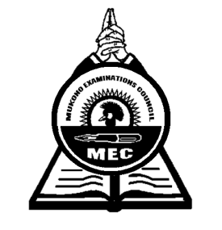

**MUKONO EXAMINATION COUNCIL**

**Uganda Certificate of Education**

**IPS ART AND CRAFTS**

Paper 2

**(DRAWING OR PAINTING)**

**FROM STILL LIFE AND NATURE**

2 hours 30 minutes

**INSTRUCTIONS TO CANDIDATES:**

*This paper is for use of the supervisor only, in consultation with the Art teacher.*

*Attention is directed to the syllabuses and to the standing instructions as given in the subject syllabus.*

*Candidates are free to attempt* ***one*** *alternative from* ***either*** *still life or nature.*

*Candidates must be instructed that* ***ruling*** *by any means is* ***forbidden.***

*The setter of the groups of the objects in this paper must interpret the sides mentioned in the question set below (i.e. left or right) according to the position of the candidates facing the objects.*

**Either: STILL LIFE**

**Alternative A**

A low table is placed in a frontal position near a wall.

On this table, place a round rolling board (used for making chapatti) towards your right. On it, towards the right, position a three-litre of “Fortune” cooking oil jerican with its lid intact in a 3 ¼ view with the handle to the right side. To the left side of the jerican on the round rolling board, put one large onion and a large ripe tomato. On the left side of the round rolling board slightly behind the setting, place a large fresh mature cabbage with one of its petals seen as if peeling off. In front of the setting to the left side, place a knife resting its handle on the cabbage in a diagonal posture with its end touching the table.

**Alternative B**

On a floor near a wall, place a bicycle leaning against its stand (prop) with its rear end directly facing the candidates. The front tyre should be turned to face your left. The bicycle pedal on your right should be at a higher position than the left one.

On the bicycle career, place and tie with rubber straps, half a suck filled with sand.

**OR: NATURE**

**Alternative C**

Make a study or studies of a fresh mature Tilapia with special attention to the head

**Alternative D**

Draw or paint an old dry branch with distinct scaly bark at least 30cm long

**Alternative E**

Draw or paint a landscape with a building seen at angle with some trees seen in the back and foreground.

***End -***